SOUTH FRANKFORT HISTORIC ZONE MAP
Murray St
Louisville Rd
Todd St
Capital Ave Bridge
Singing Bridge
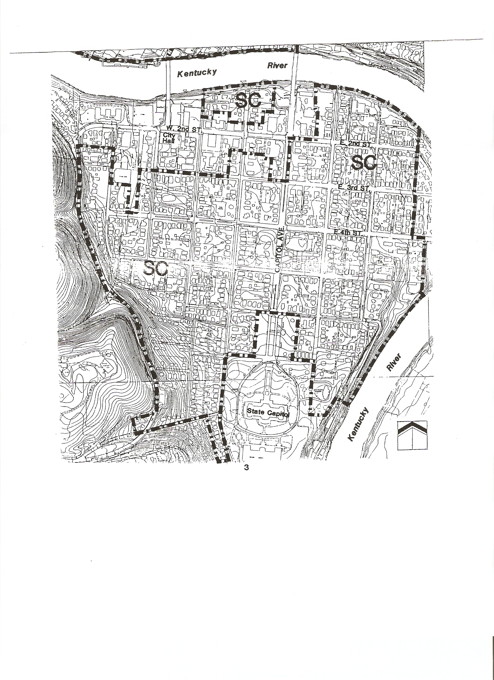
(SPECIAL CAPITAL-SC)

